# **Assignment No 2**

**Note:** **Please complete your assignment as guided by the instructor. Plagiarized work will lead to zero marks or as directed in SOP of institute. The assignment is for practice purpose therefore it is very important that you must complete your assignment on your own otherwise you might face consequences in your Exams. Dead Line of the assignment will be given by the instructor.**

1. Use nested for loops (Loops inside Loops) to construct programs that display the following patterns.
2. 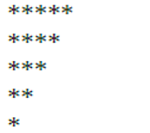
3. 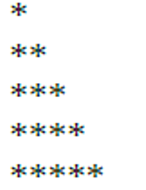
4. 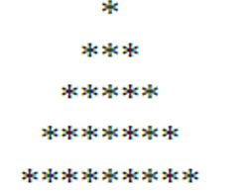
5. 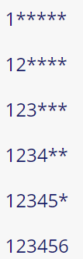

1. Write a program to display the following (using while loop):
2. 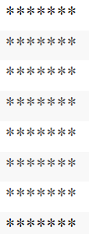
3. 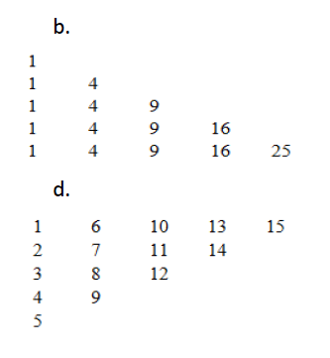
4. 